

Foundations of Programming

Assignment No.: 21
PROBLEM STATEMENT: Write a C program to copy contents of one file to another using file handling.

OBJECTIVE:

- To understand the concept of file handling in the C programming language.
- To learn how to read data from a file and write data into another file.
- To implement file copy operation using standard file handling functions.

THEORY:
File handling in the C programming language allows programs to store and retrieve data from files. Files are handled using file pointers and standard functions such as fopen(), fclose(), fgetc(), and fputc().

In this program, the source file is opened in read mode, and the destination file is opened in write mode. The program reads characters from the source file one by one using fgetc() and writes them to the destination file using fputc(). This process continues until the end of the file (EOF) is reached. Thus, the contents of the source file are successfully copied into the destination file.
PLATFORM: Linux
ALGORITHM:

Step 1: Start
Step 2: Open source file 'source.txt' in read mode using fopen()
Step 3: If file cannot be opened, display error and exit
Step 4: Open destination file 'destination.txt' in write mode using fopen()
Step 5: If file cannot be opened, display error, close source, and exit
Step 6: Read each character from source using fgetc() until EOF
Step 7: Write each character to destination using fputc()
Step 8: Close both files using fclose()
Step 9: Display 'File copied successfully'
Step 10: Stop
FLOWCHART:
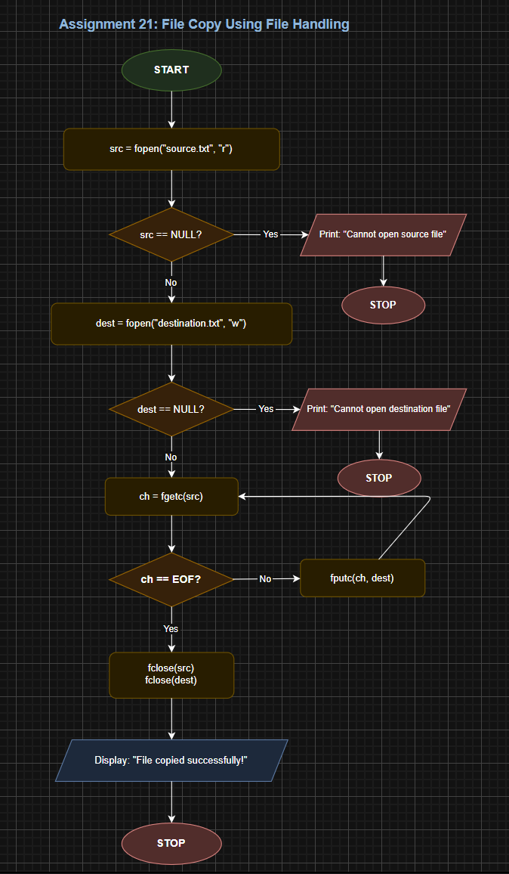
CODE:
#include <stdio.h>
#include <stdlib.h>

int main() {
FILE *src, *dest;
char ch;

// Open source file in read mode
src = fopen("source.txt", "r");
if (src == NULL) {
printf("Error: Cannot open source file!\n");
exit(1);
}

// Open destination file in write mode
dest = fopen("destination", "w");
if (dest == NULL) {
printf("Error: Cannot open destination file!\n");
fclose(src);
exit(1);
}

// Copy character by character
while ((ch = fgetc(src)) != EOF) {
fputc(ch, dest);
}

fclose(src);
fclose(dest);

printf("File copied successfully.\n");
return 0;
}

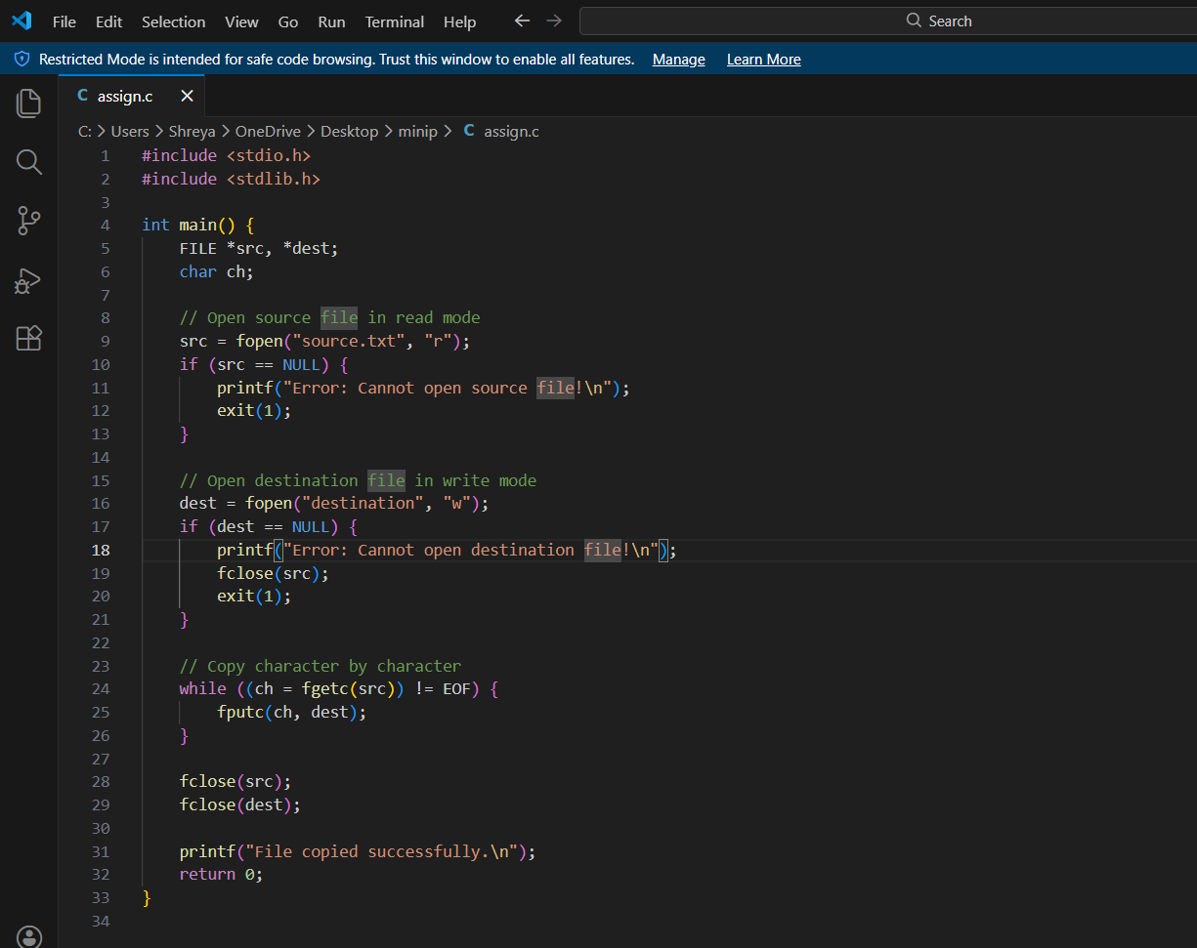

INPUT: A source file containing text data.

OUTPUT: Contents of the source file copied into another file.

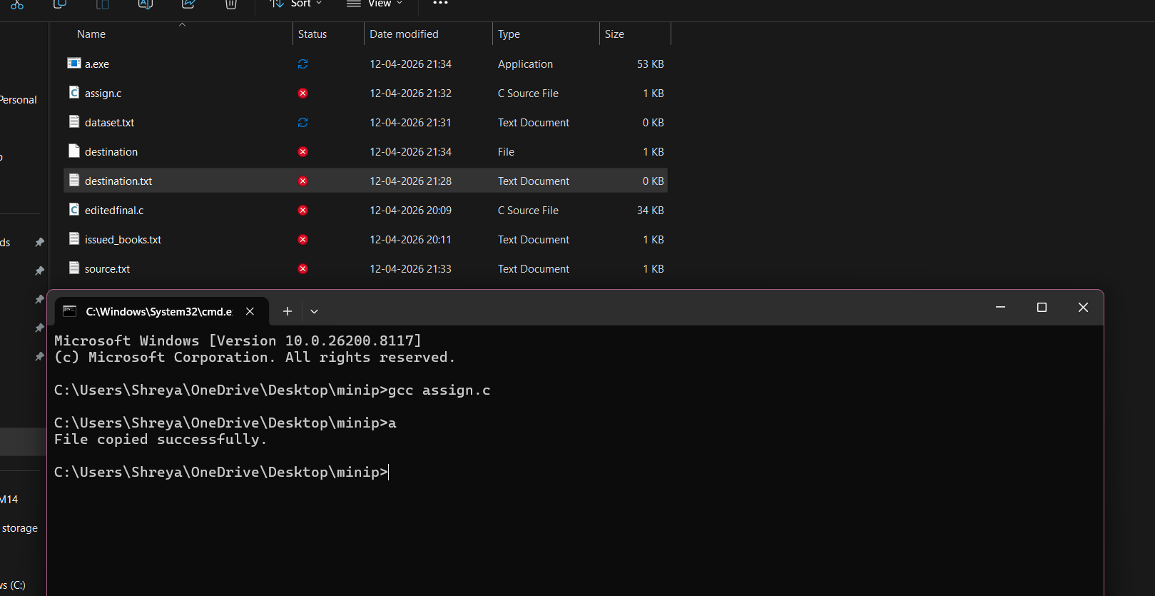

CONCLUSION: Thus, the C program successfully demonstrates file handling operations by copying the contents of one file into another using file handling functions.

